Marion County Spec Building
Marion County, South Carolina

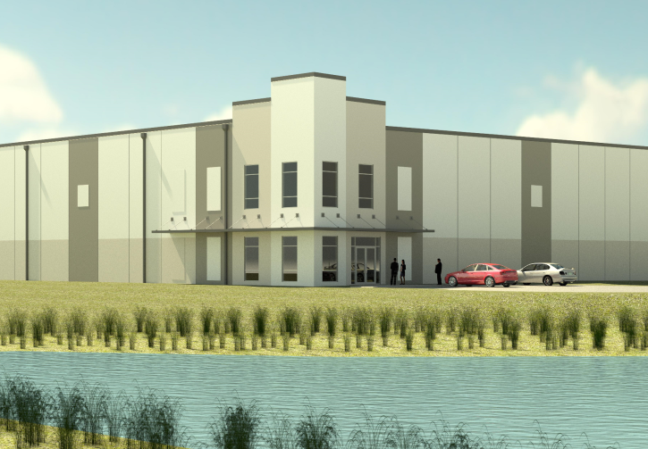
County Marion
Municipality Unincorporated
Zoning Industrial Park District
Tax Map ID 055-00-00-216-000 (Portion)
Landuse Heavy Industrial (N) Heavy Industrial (S) Heavy Industrial (E) Undeveloped Land (W)

Pricing
Pricing For Sale
Sale Price $???????
Details
Tenancy Single-Tenant (1 Building)
Year Built 2018-2019 (Under Const.)
Building Condition Excellent
Total Building Area 100,000 Sq Ft
Expandable To 240,000 Sq Ft
Site Size 15.59 Acres
Building Dimensions Rect. 400’ x 250’
Slab Thickness None
Wall Materials 8” Insulated Pre-cast Concrete
Transportation

Utilities
Water Provider Marco Rural Water
Wastewater Provider Grand Strand Water & Sewer Natural Gas Provider SCE&G
Telecomm Provider AT&T
Electric Provider Pee Dee Electric, Inc.
Alternative Gases None Available

Road Serving Building US Highway 501 By-Pass (4 Lanes) Rail Access No
Runway Access No Barge Access No
Nearest Interstate I-95 (16.00 Miles) Nearest Port Georgetown (72.00 Miles)

Nearest Commercial Airport Florence Regional (23.00 Miles) Nearest Intermodal
Facility
CSX Charleston (127.00 Miles)

Available Space Information 01

Available Area 100,000 Sq Ft Minimum Area Not Sub-dividable
Office Area None-To Suit Heated Area Not heated-Shell
Air Conditioned Area None-Shell Fire Suppression None-Shell Lighting Six (6) T5 Fluorescent Clear Height Range 30’ Min Clear
Drive-In Doors 1 Dock Doors 4 w/4 Fut.
Approximate Auto Space
Parking
11 Existing - 240 (Possible) Approximate Trailer None- To Suit
Parking

Most Recent Use None-Under Construction

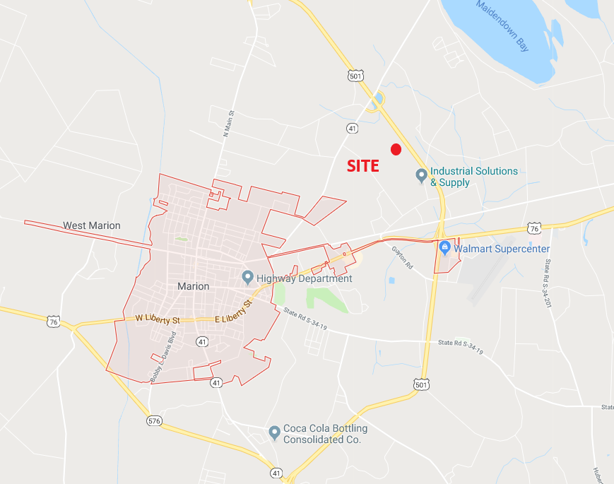

Vicinity Map – No Scale

